Dolvin pta
board meeting Minutes
Date: 18th July 2023
Time: 11:30am
Facilitator: Jessica Breithaupt

In Attendance
Board members:
Sandra Guggenheim, Elena Chung, Lindsay Phillips (remote), July Klein, Jenifer Reese, Jessica Breithaupt, Nancy Nunnelley, Samantha Ross, Sharada Chandran
Staff members: Jennifer Shaffer
Apologies: Karen Cooke, Chelsea Tullio

Approval of Minutes
The minutes for the May and July meetings to be approved at the August meeting.
- May minutes sent by Jessica 7/18.
- Motion to approve: Sandra Guggenheim
- Second: Elena Chung
- Sandra to take minutes for July minute and distribute after.

Principal’s Report (Karen Cooke)
Not in attendance.

Treasurer’s Report (Samantha Ross)
- Budget update: Changes in budget, new. Policy for submitting check reimbursement forms, committee budgets,
- Checking account balance: $91,182.28
- Savings account balance: $8,020.30
- Wells Fargo Leasing – we must cancel the printer by August because they require 60 days notice. Ask Amanda for login unless Samantha already has it?
- Budget needs to be ratified by the PTA membership. We can either ask parents to vote on / approve the budget at curriculum night or we can hold a general meeting, like we did to vote on the new board where we ask 16 people to join a zoom call and we just conduct the vote via zoom

Parliamentarian/VP of Special Events (Elena Chung)
- School supplies: Update by Sandra
- Sold 208 kits this year compared with 193 last year. PTA gets $5 per kit sold so we will receive a check for $1,040. Samantha to put a note to make sure we get this in the next few months
- Event Changes this year: Silent Auction, Pre-K/K Ice Cream Social, Math Night
- Ice-cream social – co-chair position open. Date is August 25th.
- Silent Auction separated from FFN and to be hosted in Feb
- Elena sent calendar via text for all to review. Dolvin Spirit Day on First Friday of every month except March 8th and April 12th
- Still in talks with Mathnasium about how to host Math night. Cannot host at Dolvin since the cost of hiring the facilities. We will promote and it will be hosted at mathnasium unless they pay the facilities rental fee.
- Started on lunch bunch – some changes in books for next year
- Kids care sign-up ready to go. Moved up the sign-up to August so we can have more events starting in September

President’s Update (Lindsay Phillips/ Jessica Breithaupt)
- Welcome to the New Board Members:
Co-President | Lindsay Phillips
Co-President | Jessica Breithaupt
Treasure | Samantha Ross
Secretary | Chelsea Tullio
Parliamentarian | Elena Chung
VP of Communications | Sandra Guggenheim
VP of Academic Enrichment | July Klein
VP of Health and Community | Sharada Chandran
VP of Program Funding | Jenifer Reese
VP of Special Events | Currently Elena Chung
VP of Support Services | Nancy Nunnelley
- If you know of anyone that would like to serve on the board or be more involved in PTA please tell them to contact Jessica or Lindsay.
- Be on the lookout for an email with all committee responsibilities to discuss at the first in school meeting. Please also start contacting friends, family and neighbors to help chair committees. You do not have to everything alone. You can recruit parents to help you throughout the year or just one or two that will support you. We need to be more creative this year with volunteers before and during activities. We will be asking for volunteers during membership drive on Toolkit. We will send you the contact information for those that volunteer.

- Spirit wear & swag
    - Shirts are all in and counted. We will send emails for membership/spirit out this week after approval of new membership levels. All orders are in and correct – have two extra youth medium t-shirts
    - Initial orders made before July 31st will be available for collection at the Sneak Peak event on Friday August 4th. All other orders will be sent into homeroom teachers each Friday. We will sell shirts until the sellout. Will order more if we have a surge of orders (have to place orders in dozens).
    - PTA volunteer shirts will be available for purchase at a cost price of $15.
    - New Swag is available (Koozies, Sports Cup, Magnets, Drawstring Bag, Trucker Hat) All will be available to purchase throughout the year. Will discuss how to push sells, discuss selling at events
    - Jessica asked Karen to allow Trucker Hats to be worn by students and staff on spirit days with spirit ware and she approved.
    - All swag should be in before sneak peak
    - Please post all flyers, photos etc. to your neighborhood social accounts to help drive sells.

- Membership Levels & Incentives
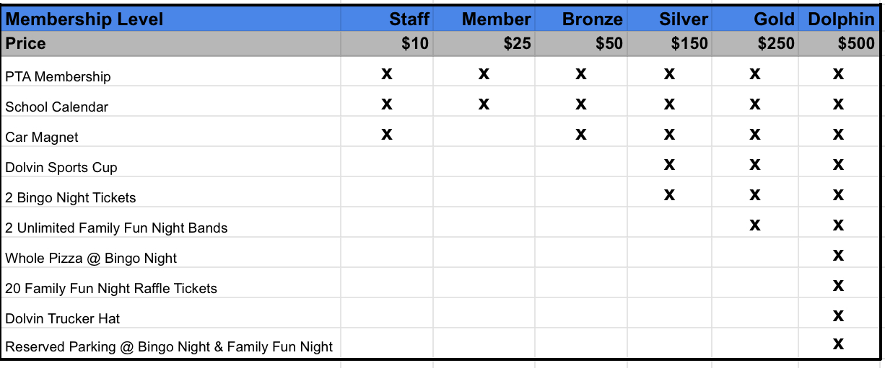
Proposed new membership levels:
The following changes to the above are:
    - Removed the $1,000 level
    - Changed Incentives to PTA related events to encourage participation.
    - Karen approved treats and recess so we will discuss how to use that at a later date (possible class with most PTA participation in each grade)
    - Membership donations to begin the week of July 17th.
- Need to remember when it comes to bingo and FFN to remind people what they have already purchased so we don’t end up having to do a bunch of refunds
- Membership sales to go live 7/21. Everyone on PTA to please purchase before and alert Jessica to any bugs in the system so we can have those ironed out before everything goes live
- Sandra to play with formatting of sneak peek postcard. Top half: To do at school. Bottom half: to do at home.

- Sneak Peek event on August 4th
    - All PTA members are requested to assist with this event, scheduled to begin at 7:30am and remain until 11:30am.
    - Members will be able to meet with their child’s teacher 30mins prior to their applicable session.
    - There will be two sessions for families to attend, dependent upon the child’s surname start letter: A-L (8am to 9am) and M-Z (9am to 10am)
    - Dash the dolphin costume; Need to ask a husband if he would be willing to wear the costume.
    - Bulletin board: Nancy (?) to decorate the board in the new Adventure Awaits theme, let us know who can help, needs to be completed before Sneak Peak
- Need to set up sneak peek on Thursday afternoon – Jessica to check to with Denise so we can make sure there is no rushing the next morning from 7:00-7:30
- Need to confirm whether business partners can come set up tables at sneak peek. Only business partners at the highest level so right now it is only children’s dental zone and mathnasium at that level.
- Tables needed at sneak peak are: Membership, business partners, spirit wear and swag, yearbook, all pro dads
- Chris Phillips to be dash on first day of school
- Kylie Roger to do Bulletin Board before sneak peek
- Landscaping for sneak peek is organized

- Staff luncheon event August 3rd
    - Nancy to lead this event. Jessica and others to assist on the day, need other Board members to help.
    - Fresh 2 Order restaurant to be considered as meal provider.
    - Meals will be boxed again this year due to budget
- Deadline for orders will be noon on 7/31

- Business partners (Bp’s)
    - Need the complete list of Bp’s, Sandra will reach out to them for new sponsorships. Several had issues last year, and are under new leadership, need to ask the marketing managers to confirm their donations with managers/owners.
    - Bp’s who contributed during the 2022-2023 will appear on the 2023-2024 calendar and banner. Jessica will supply list of Family Fun Night donors.
    - Bp’s who contribute in July will also be included in the 2023-2024 calendar and banner. Any contributions thereafter will appear on next year’s calendar and banner.
    - All members are requested to seek out any potential new Bp’s. A Bp can donate money or items for events.
- Mathnasium agreed to $1000 cash investment
- Children's Dental Zone in talks to pay for Carpool tags
- Business partner banner. Use the same one for right now. Was done right before FFN last year so no new business partners have been added since then
- Jessica to ask Footnotes about business partnership
- Sandra to reach out to Andy’s about spirit nights
- Sandra to reach out to Chaba Thai about spirit night
- Sandra to talk to Hi Five sports about spirit nights
- Sandra to talk to Yumbii about spirit nights
- Sandra to talk to Marlow’s about spirit nights
- Elena to do Kendra Scott spirit nights online – near Christmas, valentines and mother’s day

Committee Reports
Special Events: Ice Cream Social- This year its for Pre-K and Kindergarten only on 8/25. Volunteer SUG to go out First week of school.
Reflections: Need new year information (waiting for the new info to come out), get the word out ASAP, start paperwork

Announcements
PTA Clean out: We need to clean out the PTA Closet, Office and Attic. We have a lot of useful items that we could reuse as well as items that need to be thrown out. Cleaning out the Closet will be done next Thursday 7/27 during the day. If you can come help let me know.
PBIS: If you have any summer items you don’t need donate them to Student or teacher PBIS.

Upcoming important dates
July 26th- Popsicles on the Playground (PreK- 9AM, K-9:30AM)
July 31st- Last Day to order spirit-ware for sneak peak delivery
August 3rd – Staff luncheon 11:30am
August 4th – Sneak Peak
August 7th- First Day of School
August 16th – PTA General Meeting, 9:30am
August 18th- Room Parent Orientation 10am
August 25th- PreK-K Ice Cream Social
- Curriculum night tentative dates 8/22 and 8/23 @6:30pm

Meeting adjourned:

