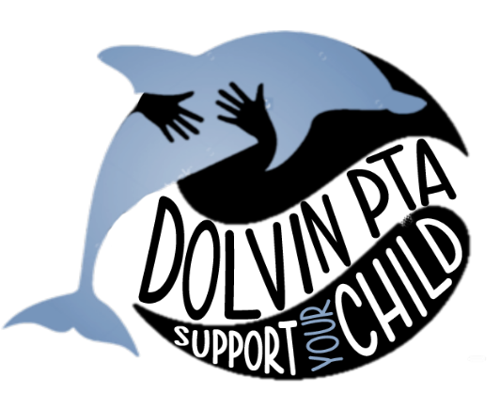 MAKE TIME TO VOLUNTEER!
Volunteers are critical to ensuring our students have the best elementary school experience possible. While volunteers are always needed in the classrooms, the PTA also needs volunteers for school wide functions and support roles. The Dolvin PTA offers many volunteer jobs to fit a variety of schedules and interests. Whether you are a full-time, part-time or stay at home working parent, we have something for everyone. Please take a moment to choose one or more areas which best fit your interest(s). Filling out this form does not commit you to anything. A PTA representative will contact you as events or needs come up to see if you are available. We hope you will join us and be a part of your child’s Dolvin experience.
Your Name: __________________________________ Child’s Name: ______________________________
Email: __________________________________ Child’s Grade: ______________________________
Phone # __________________________________

( ) Academic Enrichment – Lunch Bunch Book Club (3rd, 4th & 5th grade), Reflections, Rockin’ Reader (K only),
International Day

( ) Student Enrichment – Spirit Day, School Store, KidsCare (4th & 5th only), Field Day, Yearbook, Book Fair

( ) Support Services – Lead Room Parent, Support Room Parent, Spirit wear, Box tops, Bulletin Boards

( ) Dolvin Discovery Lab – volunteer to assist teacher

( ) Marketing and Communication – Community Fundraising, Welcome Committee, Social Media

( ) Hospitality – Family Fun Night (FFN), Bingo Night, K-2 Ice Cream Social, SAW (Staff Appreciation Week),
Volunteer Coffee

( ) Health & Community – Hands on Dolvin, Watch Dogs, Hearing & Vision Screening, White Ribbon Week

*A detailed description of each of the volunteer opportunities can be found on the dolvinpta.org website

